**NATIONAL INSTITUTE OF TECHNOLOGY CALICUT**

Department of Electronics and Communication Engineering



**EC4092: DIGITAL COMMUNICATION LAB**

**Experiment No.5**

**CDMA SPREADER AND DE-SPREADER**

**(HARDWARE)**

***Group Members:***

B Veda Sree-B150734EC

B Sravani-B150783EC

C Vamsi -B150530EC

Ch Lakshmi Priyanka-B150837EC

**AIM:**

To design and implement a CDMA spreader and de-spreader for a data rate of 1Kbps and processing gain 7 using digital gates. The data may be derived from the original clock by dividing it.

**COMPONENTS USED:**

IC 74190- Synchronous UP/DOWN counter

IC7473- JK flip-flop

IC7474- D flip-flop

IC 7408- AND gate

IC 7404- NOT gate

IC 7486- XOR gate

**THEORY:**

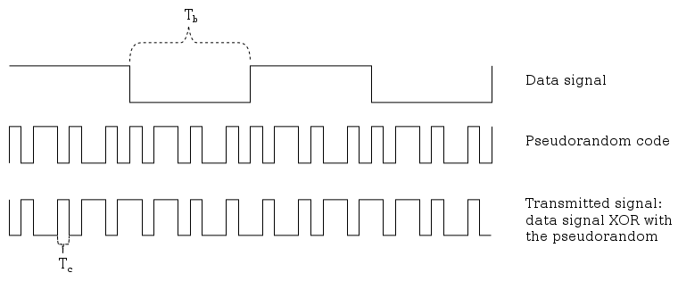

SPREAD SPECTRUM TECHNIQUE

Let B(t) be the baseband signal and e(t) be the PN sequence,

- - - - - - - - spreaded signal

The baseband signal is retrieved at the receiver side by multiplying it with same PN sequence, in perfect synchronization with the transmitter.

- - - - - - - - de-spreaded signal

Where ‘^’ represent XOR operation.

**DESIGN:**

Clock frequency = 7 KHz

Processing Gain = {\displaystyle T_{b}/T_{c}} = 7

=7{\displaystyle T_{b}/T_{c}} is obtained by dividing the clock by 7, using a mod 7 counter.

This divided clock is given as clock to a JK flip-flop to generate data signal which is 0 for 7 clock cycles and 1 for next 7 clock cycles.

Let the 7-bit pseudo random sequence be 0001011.

Length of sequence S =7 bits

$$S≤2^{N}-1$$

So, number of flip-flops required, N=3

|  |  |  |  |
| --- | --- | --- | --- |
| Q1 | Q2 | Q3 | D1 |
| 0 | 1 | 1 | 0 |
| 0 | 0 | 1 | 0 |
| 0 | 0 | 0 | 1 |
| 1 | 0 | 0 | 0 |
| 0 | 1 | 0 | 1 |
| 1 | 0 | 1 | 1 |
| 1 | 1 | 0 | 0 |

|  |  |  |  |  |
| --- | --- | --- | --- | --- |
| Q2Q3 | 00 | 01 | 11 | 10 |
| Q1 |
| 0 | 1 | 0 | 0 | 1 |
| 1 | 0 | 1 | X | 0 |

D1= Q1Q3 + (Q1)'(Q3)'

= (Q1) ^ (Q3)'

**CIRCUIT DIAGRAM:**

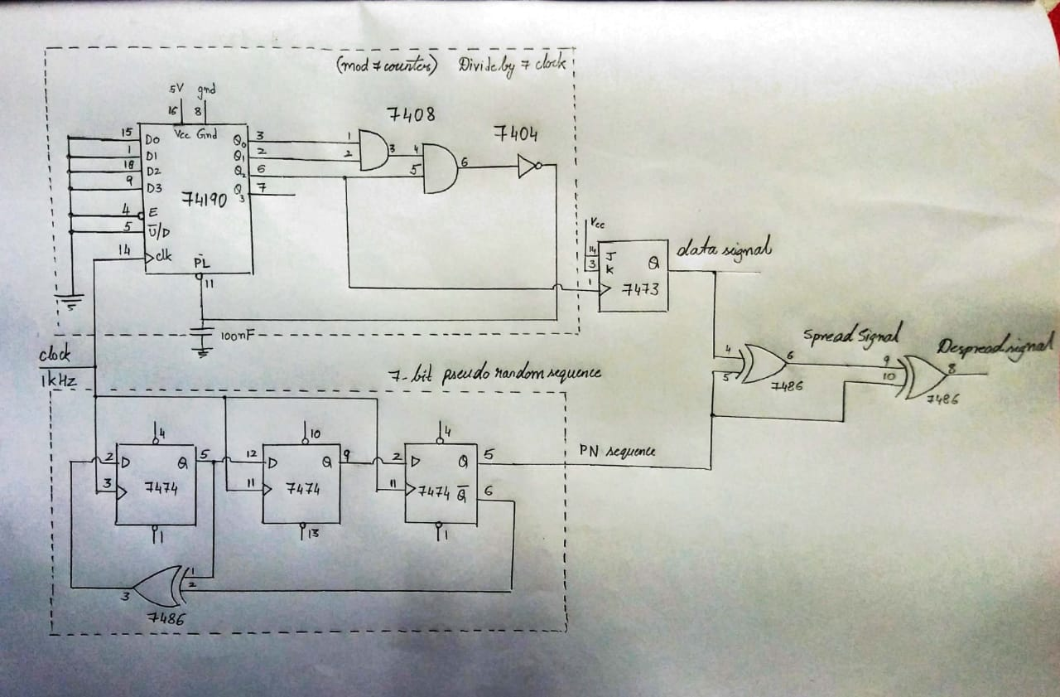

**CIRCUIT ANALYSIS:**

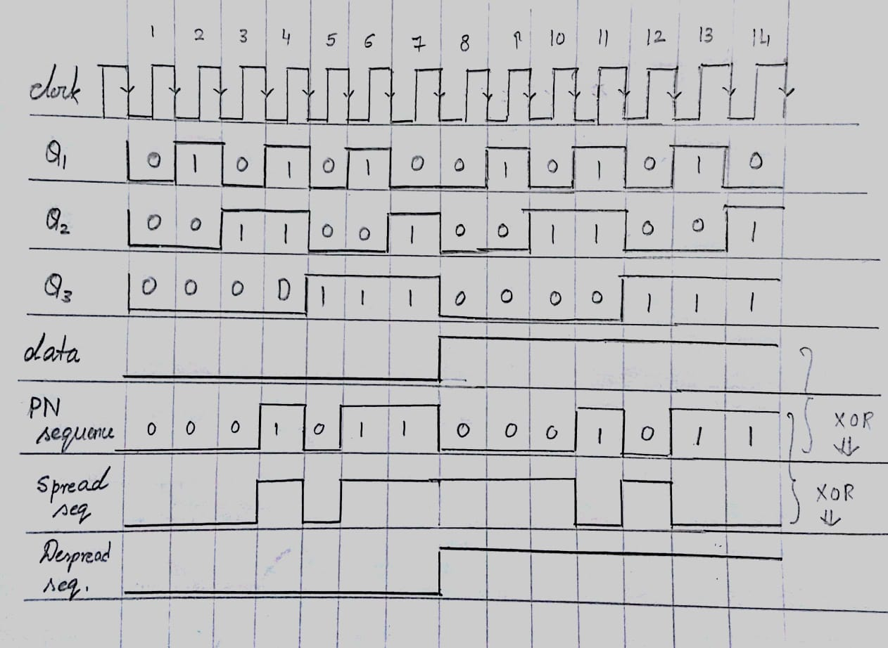

**OBSERVED OUTPUT:**

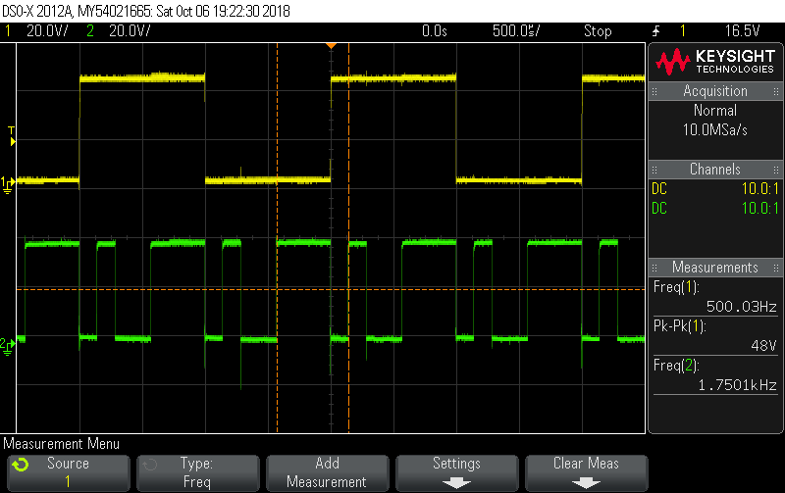

**Upper signal is the Data Signal**

**Lower Signal is the PN sequence.**

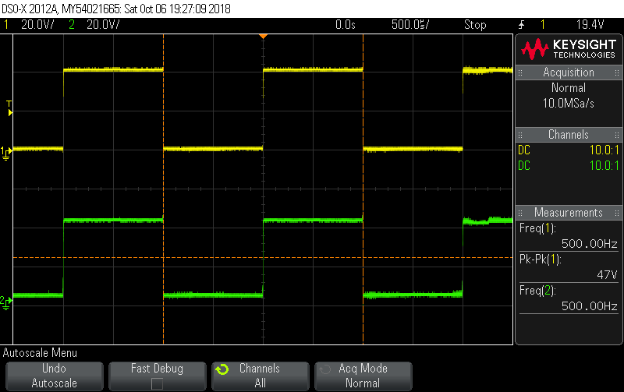

**Upper Signal is Data Signal**

**Lower Signal is De Spread Signal.**

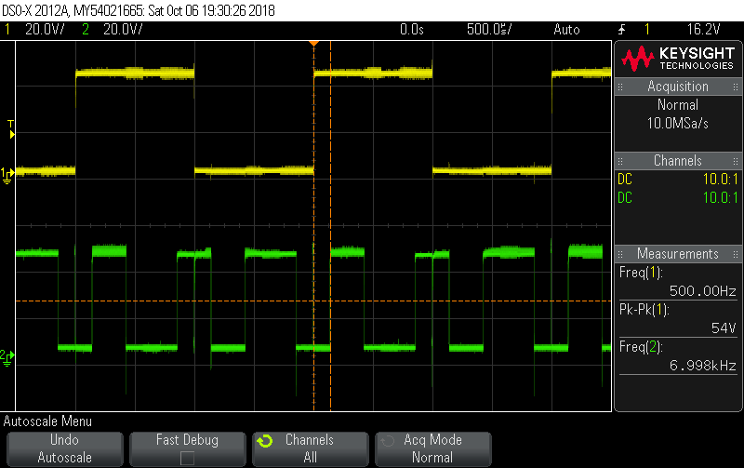

**Upper Signal is Data Signal**

**Lower Signal is Spread Signal.**

**OBSEVATIONS & INFERENCES-**

* The message signal can be retrieved at the receiver side by XORing it with same PN sequence, in ***perfect synchronization*** with the transmitter. If it’s not in synchronization, it results in errors in de-spreading.
* The initial state of the PN sequence generator should be checked to be one of the states of our designed sequence, else it remains in the same state.

**RESULT:**

The designed circuit was set-up and tested and output waveforms were verified.